**Database System Analysis**



**Bright House Apartment**

**Project Phase 1**

**By**

Mr. Anon Kangpanich 6088053

Ms. Tanaporn Rojanaridpiched 6088146

Mr. Tanawin Wichit 6088221

Mr. Pornthep Duangdarw 6088038

A Report Submitted in Partial Fulfillment of

the Requirements for

**ITCS413 - Database Design**

Faculty of Information and Communication Technology

Mahidol University

2019

Table of Contents

Motivation 2

An Overview of the Current System 3

Mission Statement 15

Mission Objectives 15

Scope and Boundary 16

Subsystem Definitions 16

• Customer Relationship Management 16

• Booking 16

• Customer Payment 17

• Room Management 17

• Room Service 17

• Employee 17

Major User View & Operations 18

**BranchManagement** Users' View 20

**BranchEmployee** Users' View 20

**Customer** Users' View 21

User's Requirement Specifications 21

BranchManagement 21

**DATA REQUIREMENTS** 21

**TRANSACTION REQUIREMENTS** 23

BranchEmployee 26

**DATA REQUIREMENTS** 26

**TRANSACTION REQUIREMENTS** 27

Customer 29

**DATA REQUIREMENTS** 29

**TRANSACTION REQUIREMENTS** 30

System Specifications 30

Initial Database Size 30

Database rate of growth 31

Types and average number of record searches 31

Networking and shared access requirements 31

Performance 31

Security 32

Backup and recovery 32

Legal issues 32

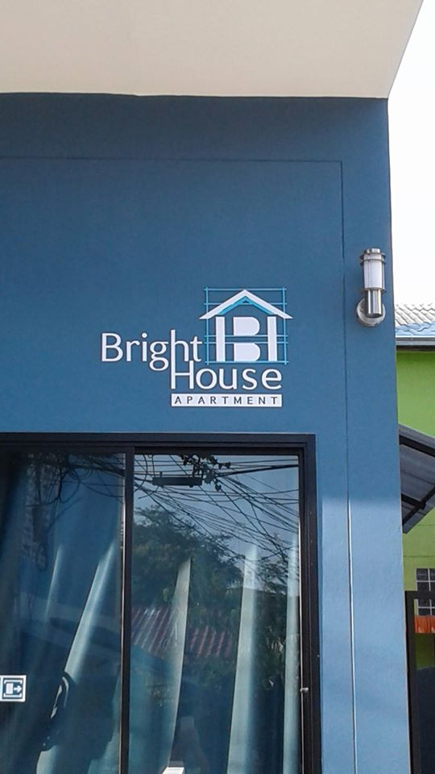**Project Title**: Bright House: Apartment Management System



# Motivation

Bright House apartment is an apartment chain based in Pattaya City, Chonburi, Thailand established in 2017. It has 10 branches scatter throughout Chonburi. Each Branch has 10 - 16 rooms. It offers accommodations at reasonable prices for daily and monthly rental. Most of its customers are foreigners; therefore, additional information such as passport and Visa number has to be kept. Despite its numerous branches, Bright House still using traditional ways of operating. For example, many processes such as accounting, room information, utility tracking, room reservation, and room scheduling are done manually by employees using papers. Thus, during high seasons, front counter employees have to deal with complicated and redundant tasks including searching for available rooms. Moreover, with the director's vision of expanding the business, a database system must be introduced in order to introduce non-existing customer relationship management and mitigate human involvements, which are erroneous. Therefore, a database system must be developed to support the operations of Bright House.

# An Overview of the Current System

A brief description of Bright House's business processes is provided. Bright House is specialized in an apartment for rent especially for foreigners in Pattaya, which is a popular traveler destination, and nearby regions. Bright House currently has 10 branches operated by approximately 80 staff. There are various business processes that require forms and reports.

**Room Schedule 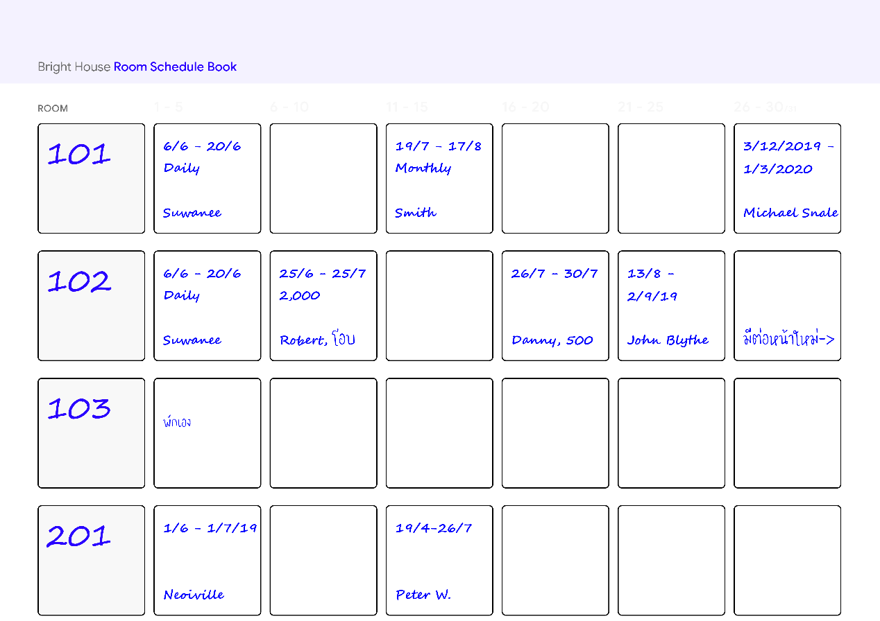Book Page (Form)**

When a customer asked the staff at the counter, in a branch of Bright House, for booking information and available rooms, the staff will look up in the Room Schedule Book which belongs to a branch and includes a representation of a timeline that emphasizes the availability of each room identifiable by using room number. This process usually takes a considerable amount of time as the staff has to skim through several pages. The schedule will be updated when there are new changes to any room. An example of room 101, 102, 103 and 201 **Room Schedule Form** is shown in ***figure 1.***

**Reservation Form**

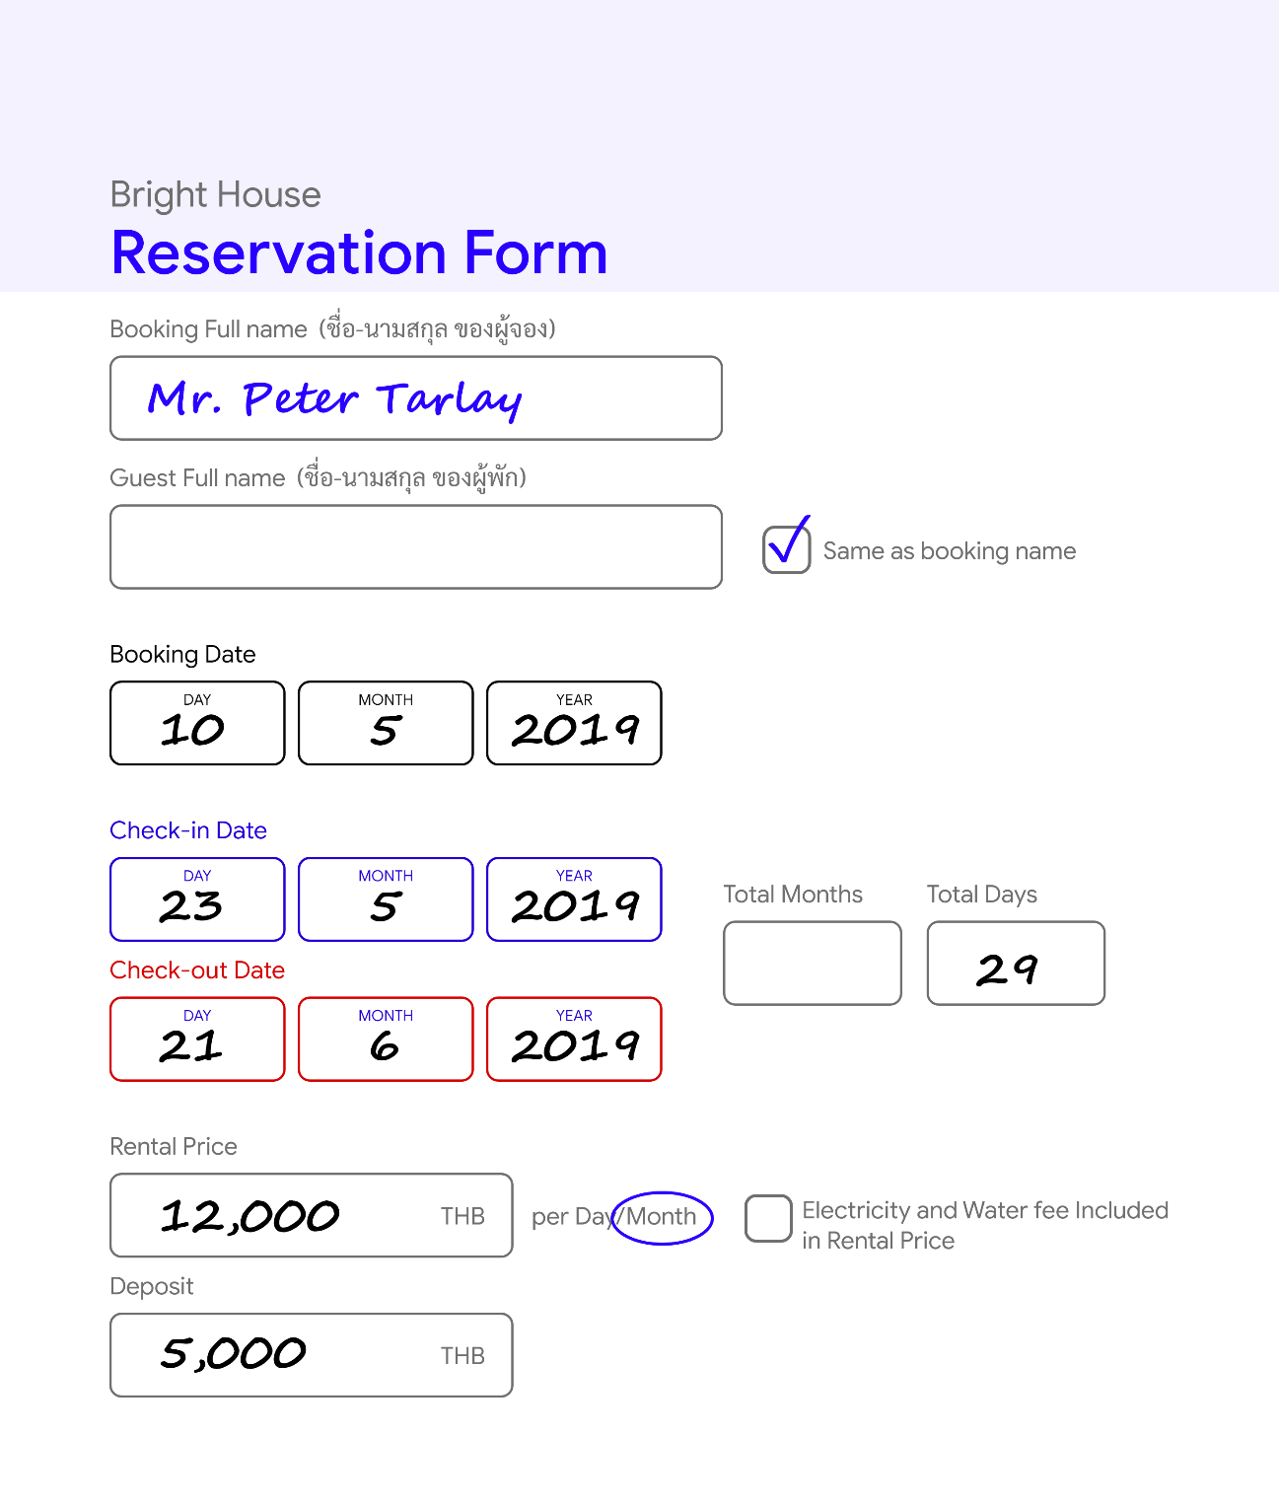

To facilitate customers who want to stay during high seasons, where most rooms are occupied, the reservation form is used to keep track of room availability, a reservation can be made by sending an email, making a phone call or walking into a Bright House branch. When an appointment is made at a counter front or remotely (e.g. phone, email, or social media direct message), the staff will take care of writing the reservation form and update the room schedule. An example of Mr. Peter Tarlay's **Reservation Form** is shown in ***figure 2***.

**Check-in/out Form**

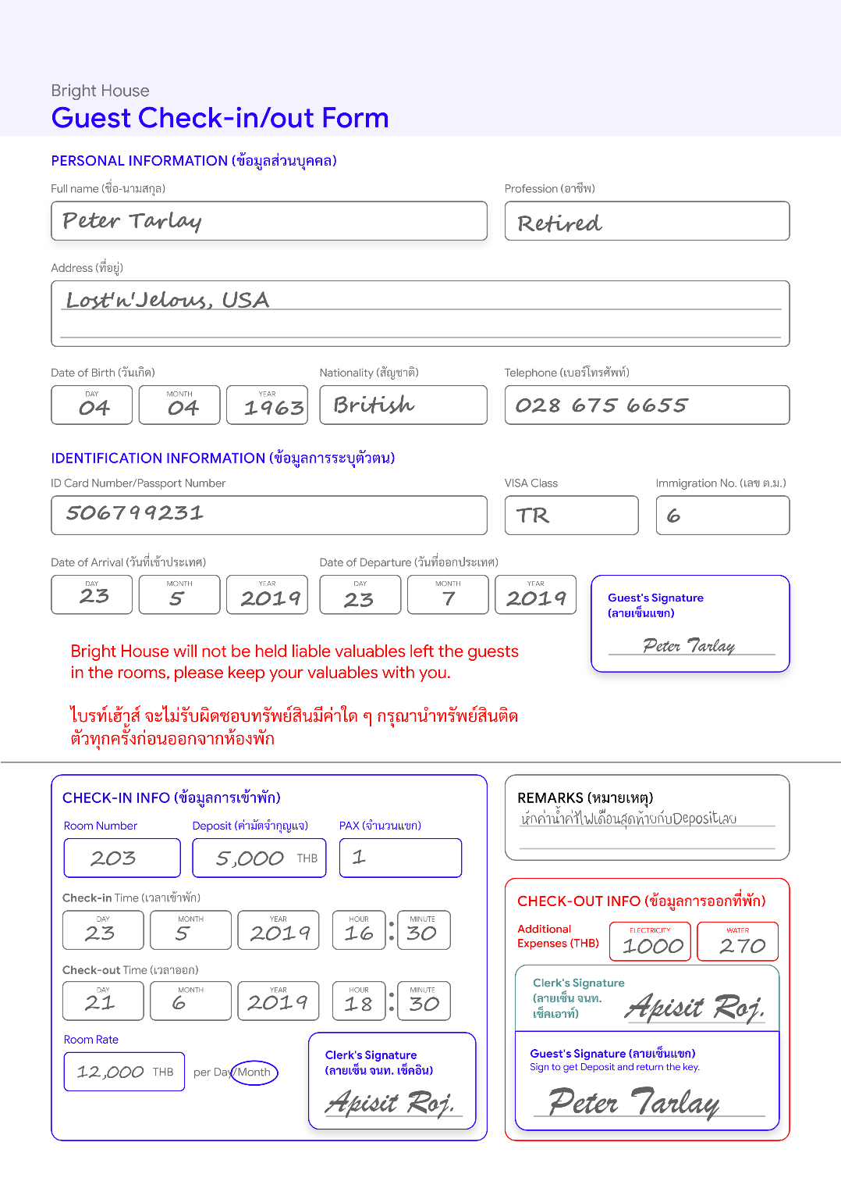

Once a customer desires to book and stay at one of Bright House branches, to keep track of customer information and their stays at Bright House, the staff at the front counter of that branch will prompt the customer to enter their personal information on the Bright House check-in/out form. The form is used will be kept and organized grouped by rooms. Once everything is filled, the staff will verify and shows the customer a room. ***Figure 3*** shows the **Check-in/out form** of Mr. Peter Tarlay.

**Key chain Rental Report**

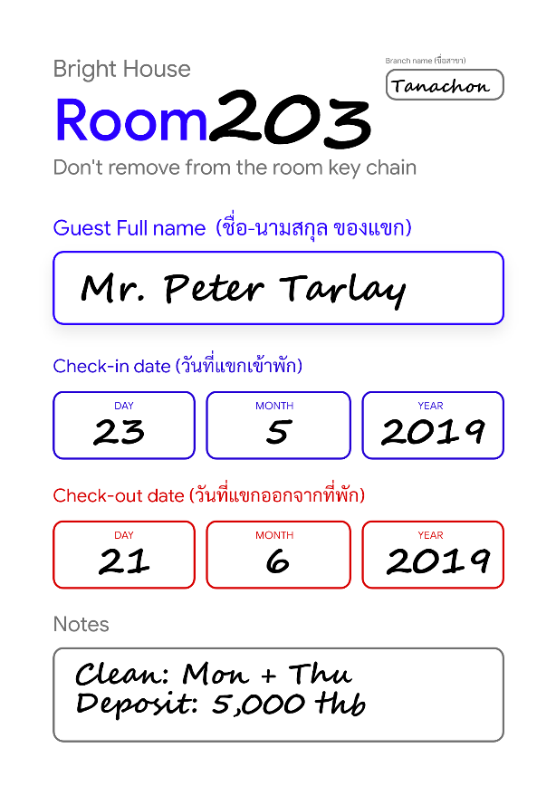To keep track of backup keycards of each occupied room at the counter, the Key Chain Rental Report is attached to each keycard to identify the rent and its customer as well as the room. The backup keycard will be used extensively for cleaning services. ***Figure 4*** shows an example of a room 203 **Key Chain Rental Report**.

**Room Supply List (Form)**

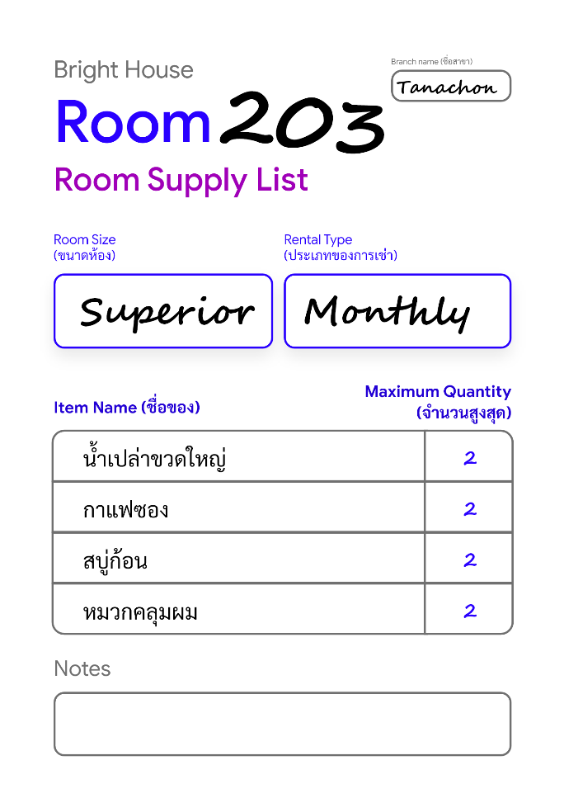To keep track of the maximum amount of room supplies to give, the Room Supply List will be given to each room for employees to check and refill those supplies to a specified amount depends on the rental type. If the rental type is monthly, then room supplies will be provided at the start of the rental once. If the rental type is daily, then room supplies will be provided daily, Furthermore, the maximum amounts of supply are varied based on customer requests, the rental type and the rental period of a stay. When a customer request is given, the staff will jot down the description of the request onto the supply list and determine the total amount of supplies that needed to be provided. ***Figure 5*** shows the **Room Supply List Form** for room number 203.

**Monthly Room Cleaning Check List (Form)**

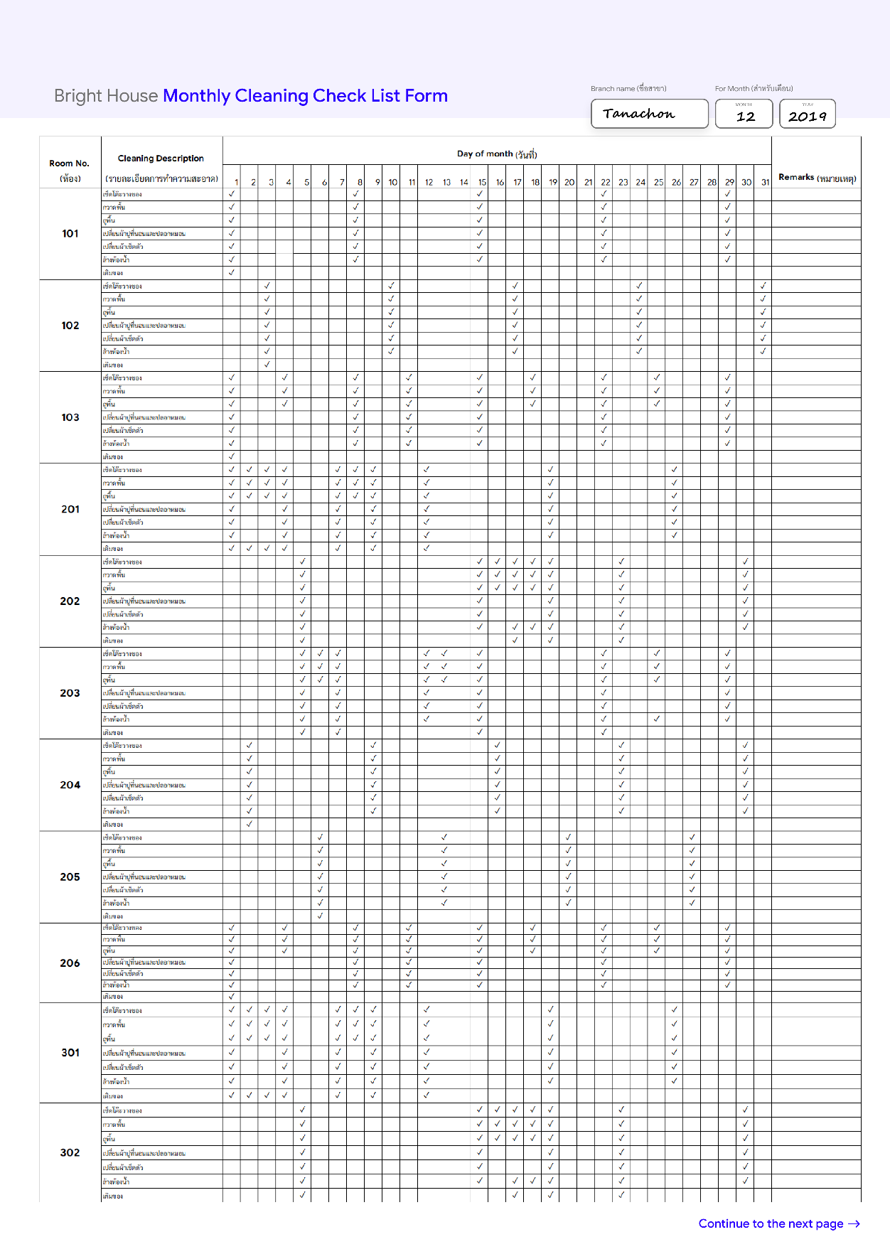

To keep track of room cleaning service over a month, the Monthly Room Cleaning Check List is used as a form for cleaning staff to track, schedule and record their service which consists of multiple subtasks. An example of the **Cleaning Check List** for December 2019 is illustrated in ***figure 6***.

**Branch Supply Stock List (Report)**

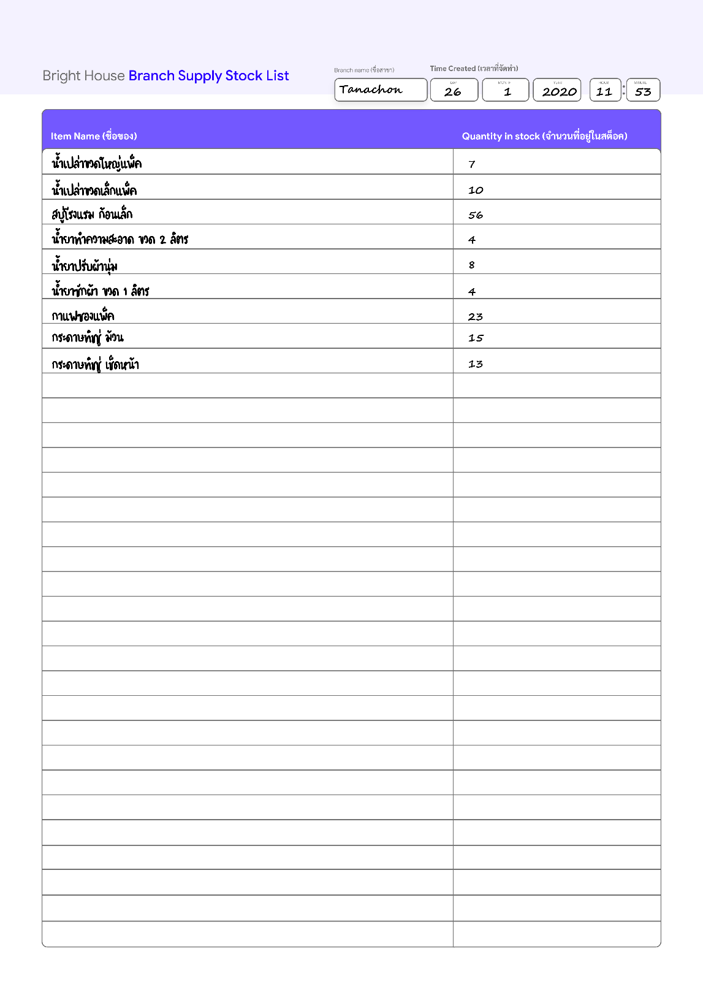

Once a Bright House branch needs to restock their supplies, a Branch Supply Stock List is generated to be used to decide which items to resupply. ***Figure 7*** shows the Stock List generated on 26 January 2020.

**Room Utility Report Form**

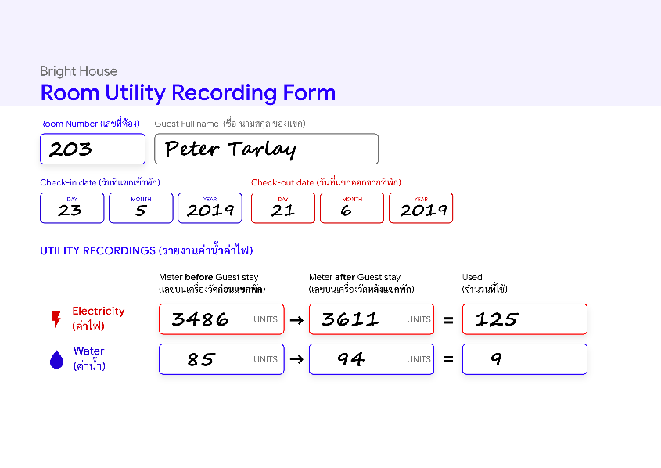To calculate the utility costs and charge customers in the month, in each monthly stay, the total amount of water and electricity utilities that can be read from meters of a room will be recorded in units by an employee using the Room Utility Report Form as shown in ***figure 8*** which illustrates an example for room 203.

**Room Utility Summary**

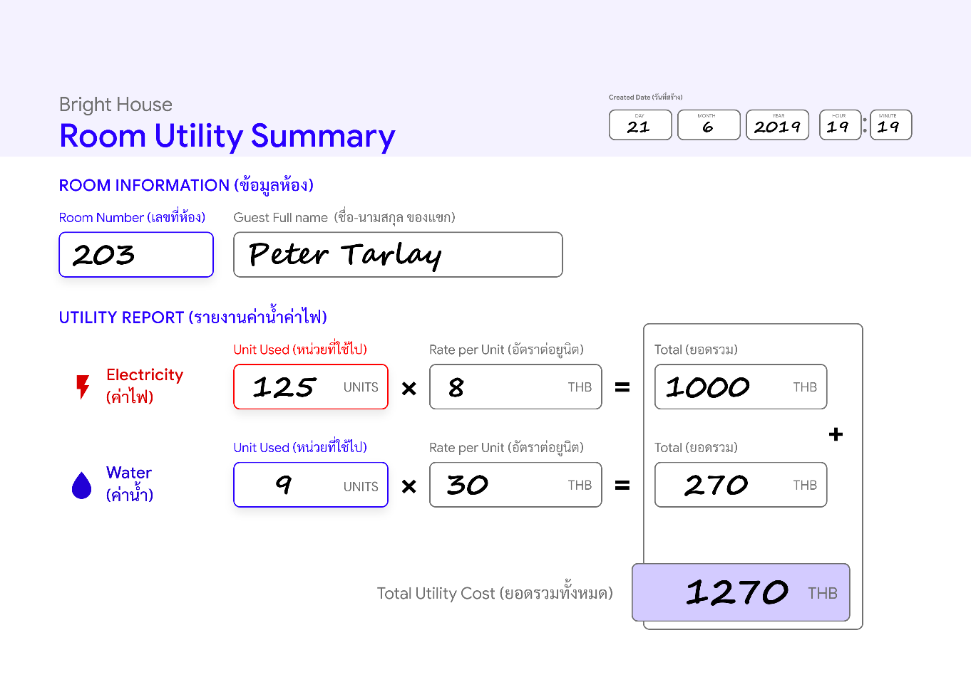

In order to charge monthly-stay customers for electricity and water cost, both costs must be calculated by multiplying the total unit used and the price per unit and recorded to the Room Utility Summary as illustrated in ***figure 9***. The monthly-stay customer will have to pay the utility every month as long as the duration of their stay.

**Occupied Room List (Report)**

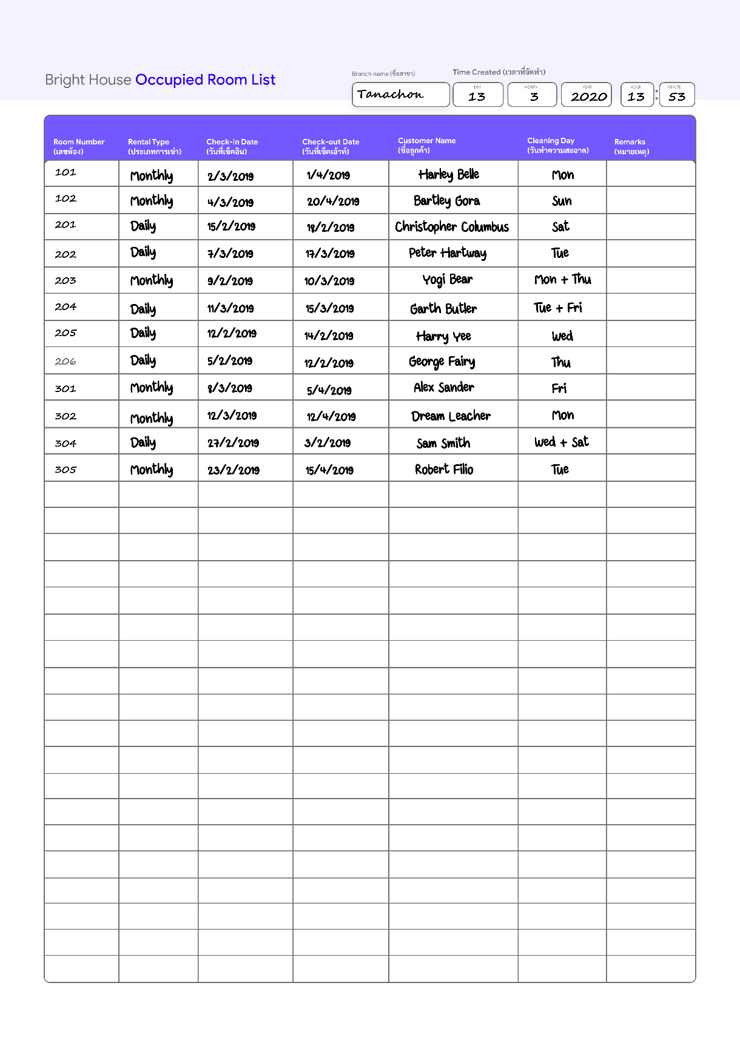

In order to make keeping track of guests in a branch easier, the occupied room list is used. Cleaning personnel, security, a branch manager could use this report to adjust their services efficiently. As shown in ***figure 10,*** the **list of the occupied rooms** of the branch Tanachon is illustrated.

**Payment Bill (Report)**

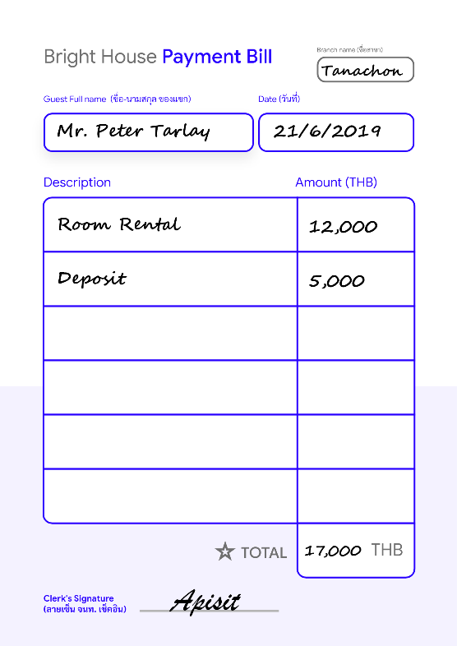To provide evidence of customer payment, a payment bill is written every time the customer checks in and the bill will be completed when the rental fee is paid at the counter in the branch that they stay. Moreover, the deposit will also be returned to the customer. A **payment bill** is also created when other types of transactions are made. For example, a customer requests extra cleaning services, or purchase bottles of fresh water, etc. ***Figure 11*** illustrates a payment bill for Mr. Peter's rental. Please note that utility costs will not be recorded inside the bill because they will be charged monthly separately by using the **Room Utility Summary** report.

**Employee Application Form**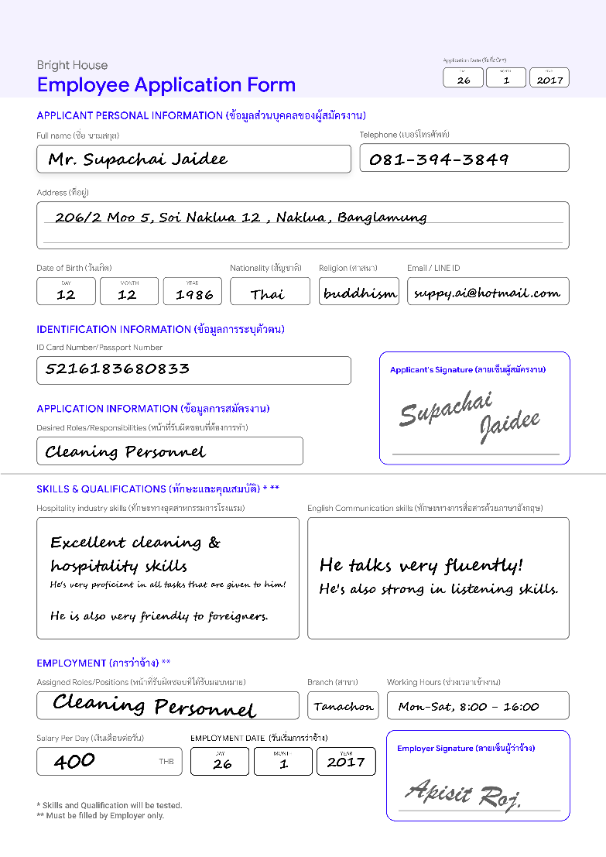

To facilitate servicing, payroll, branch stock tracking, and accounting, when a job applicant applies for a job at Bright House, the applicant must write their information to the registration form. Later the applicant will be tested in various hospitality skills. Each applicant can have multiple tasks given by the branch manager. Moreover, application date, work experience, and English skills will also be recorded as well. ***Figure 12*** shows Mr. Supachai Jaidee's **application form**.

**Branch Employee Listing (Report)**

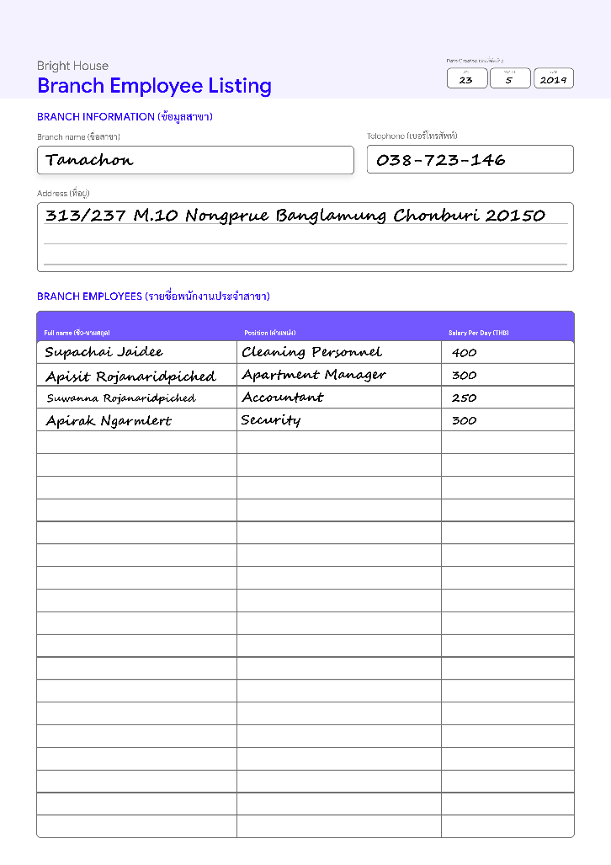To help a branch manager in managing employees, a branch employee list is used to shows the name, position, and daily salary for all employees as shown in ***figure 13***.

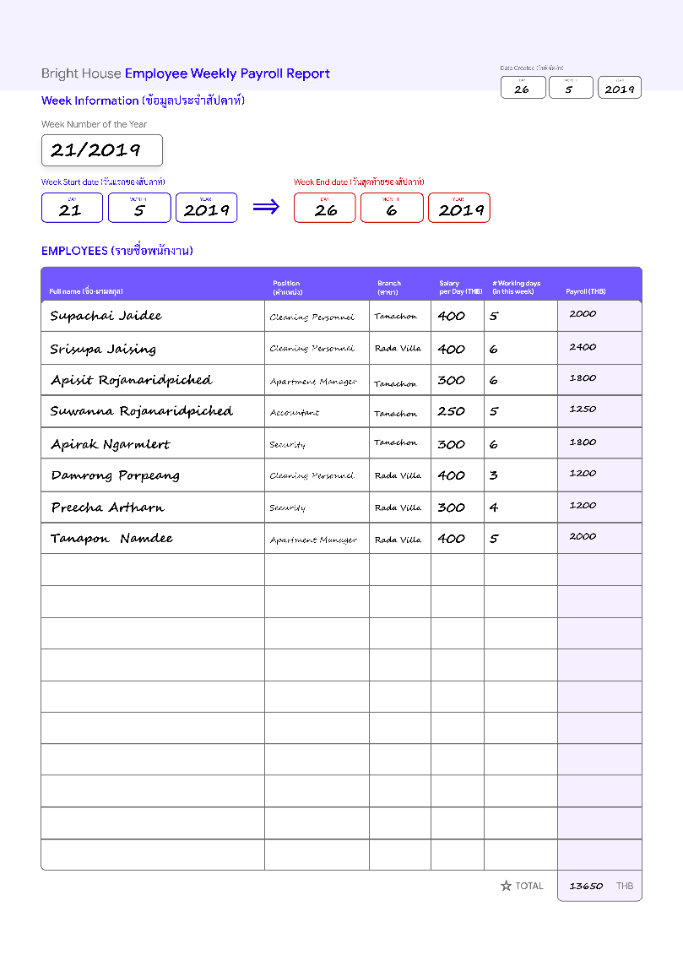

**Employee Weekly Payroll Report**

Typically, Work attendance and work hours will be kept for every employee every week. Later the branch manager will payroll their employees depends on their work hours over the week and performances. To facilitate the payroll process, an employee Weekly Payroll Report, as shown in ***figure 14***, must be created before any payroll transaction could happen.

**Ledger (Form)**

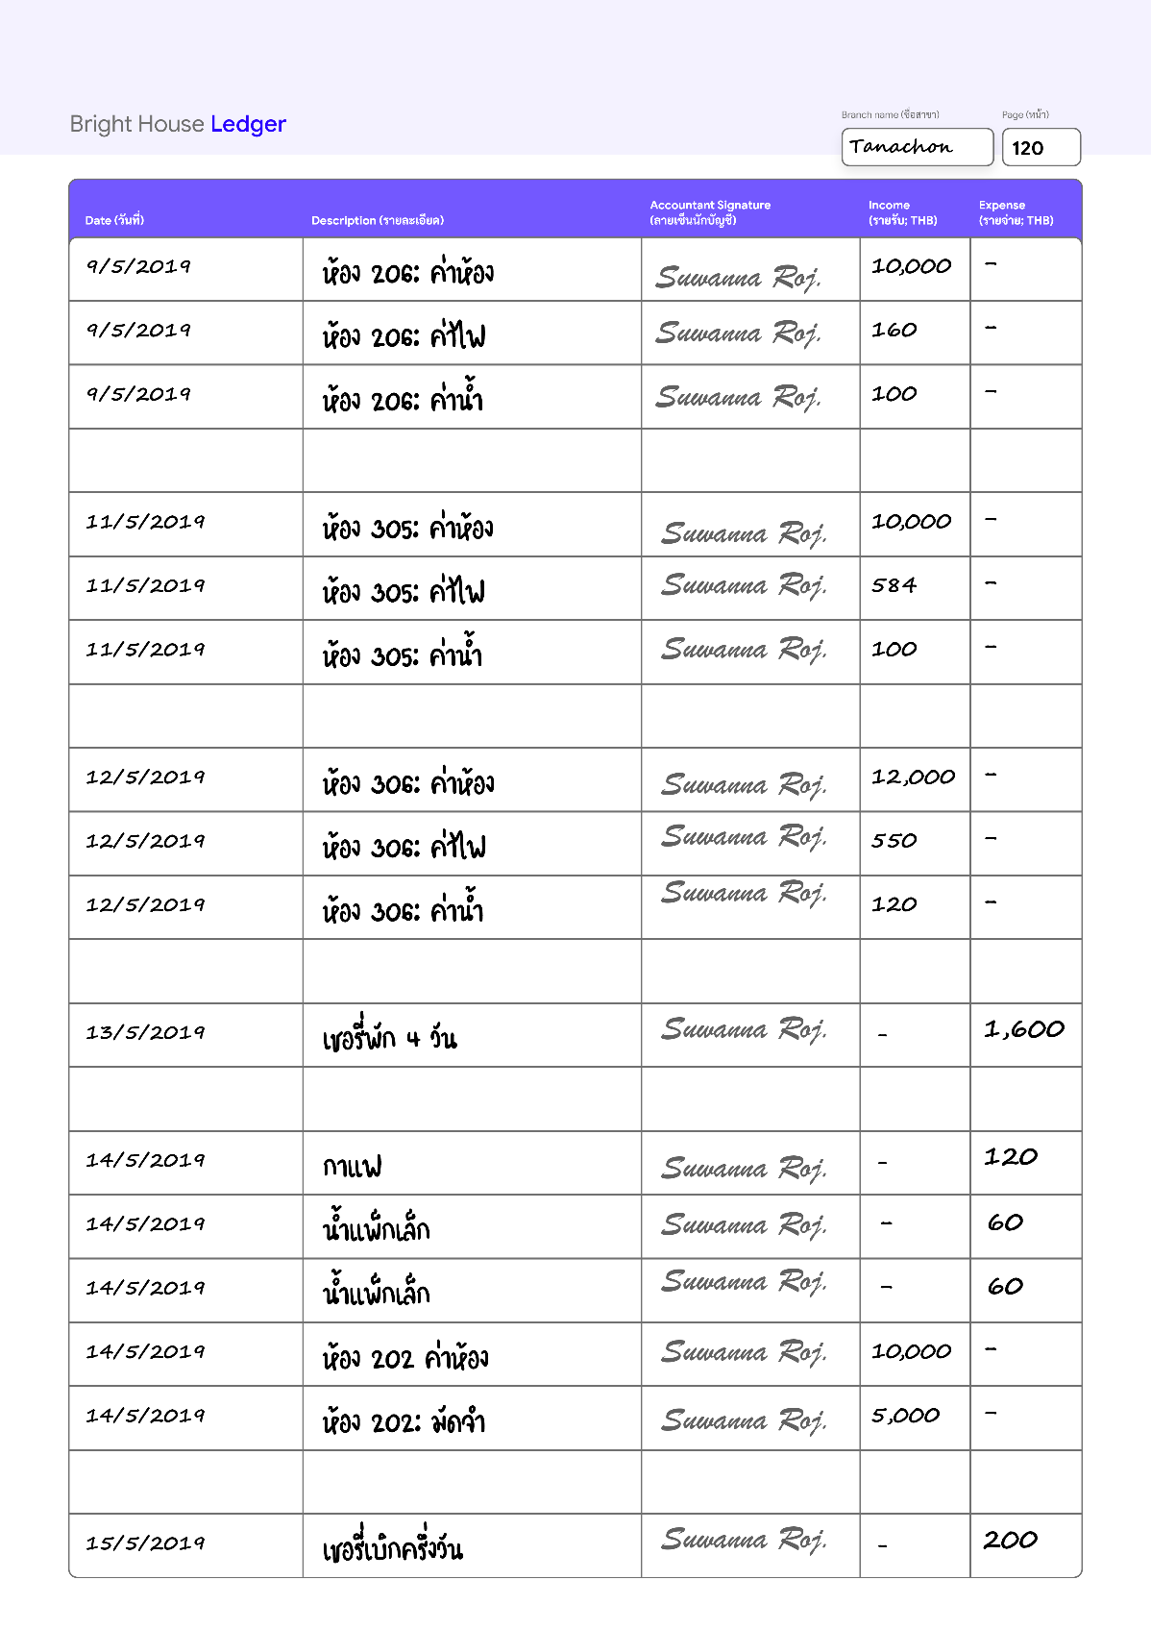

Similar to most businesses, to record every financial transaction related to Bright House, each branch will have its own **financial Ledger**, as shown in ***figure 15***, managed by a branch manager, that records incomes and expenses in day-by-day operations.

**Branch Supply Tracker (Form)**

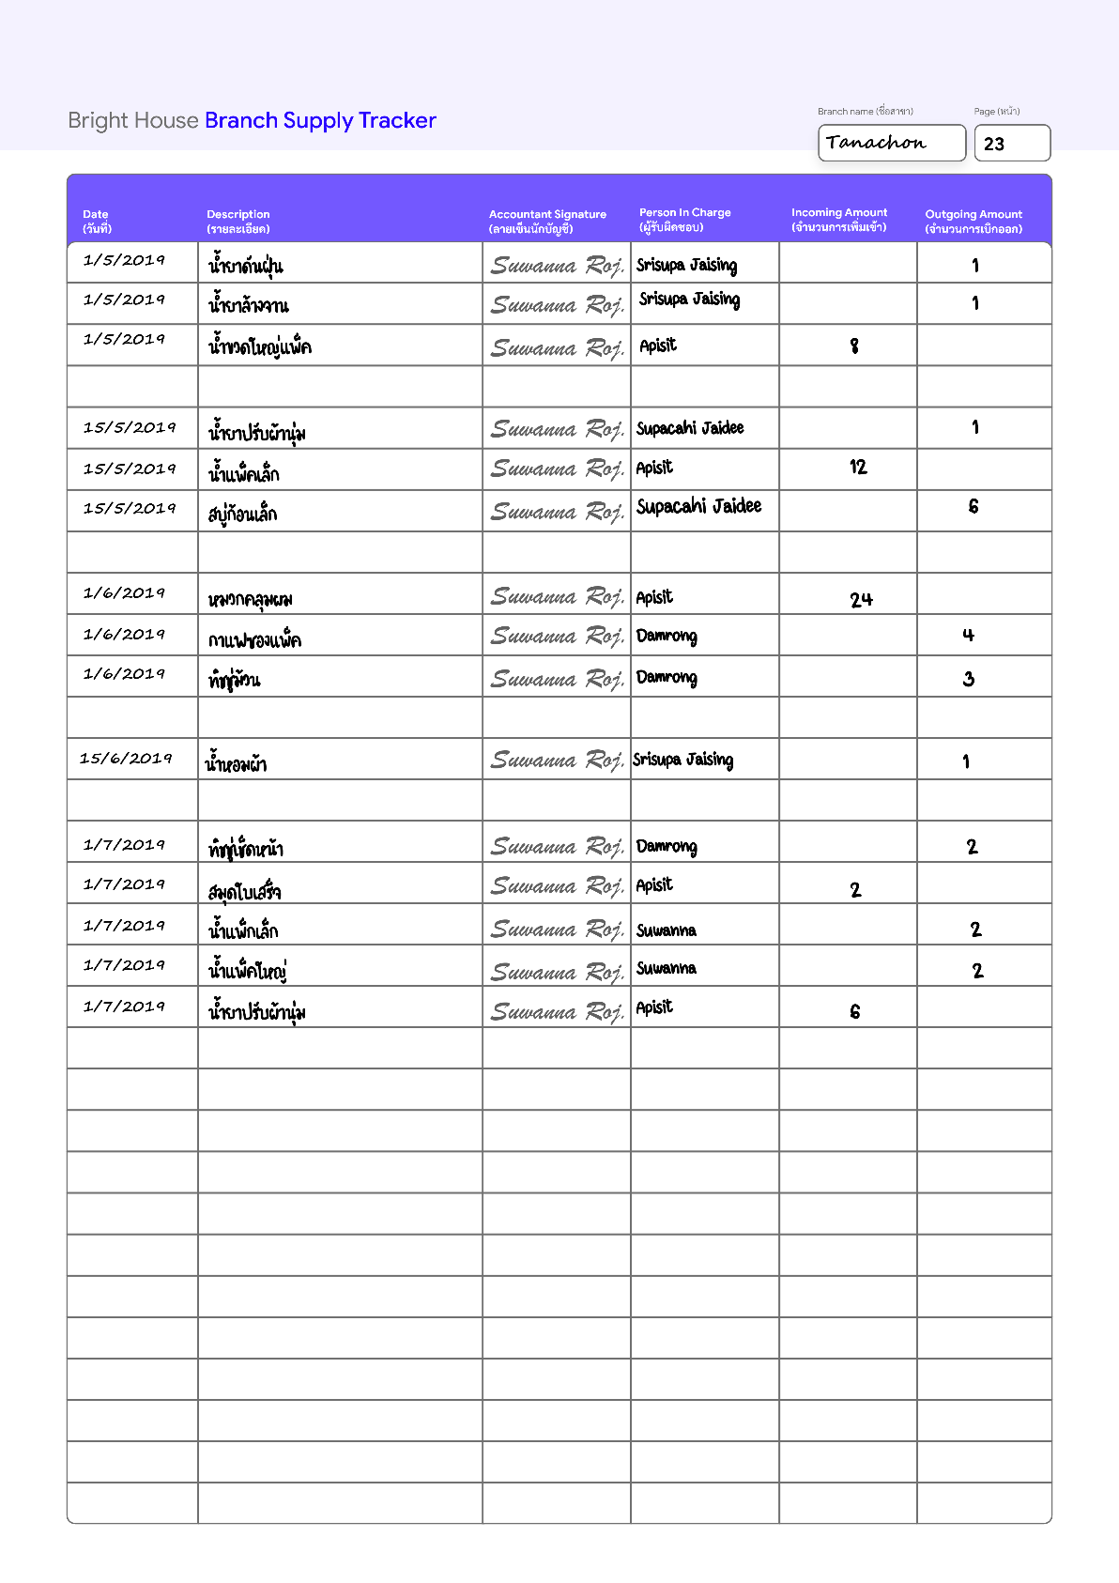

In order to monitor transactions of supply with efficiency and transparency in each branch, Branch Supply Tracker is used as a form by a branch accountant. ***Figure 16*** shows **the supply tracker** used by Tanachon Branch.

**Customer Feedback Form**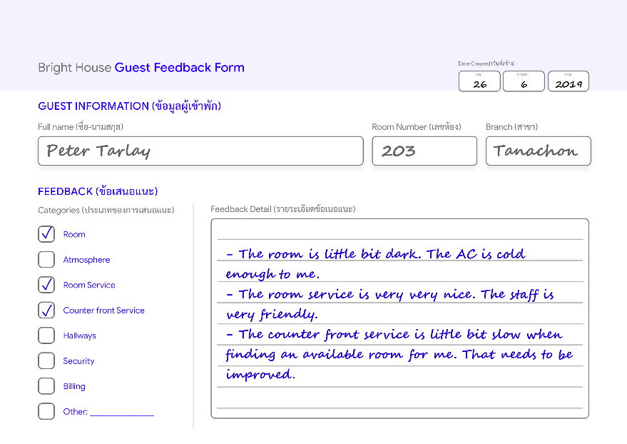

To improve overall services, all guests can give their feedback during or after each rental. All feedback will be kept by a branch manager for further improving processes. ***Figure 17*** shows Mr. Peter Tarlay **feedback**form after his rental ends***.***

# Mission Statement

The purpose of the **Bright House database system** is to manage, organize and secure all operational data that facilitates unified efficient high-quality service and resource management through minimized data redundancy and consistency.

# Mission Objectives

The Mission Objectives for the **Bright House database system** are specified as follows:

* To manipulate (insert/update/delete) data of apartment rooms, room supply services, employees, rentals, customers, room utility and payment.
* To facilitate various time-consuming processes such as room assigning and room scheduling.
* To enable detailed customer data and feedback data capture that can facilitate customer relationship management.
* To report on branches, employees, rooms, room servicing, supplies, rents, customers, check-in, and check-out instances.
* To perform searches on branches, employees, rooms, room servicing, supplies, rents, customers, check-in, and check-out instances.

# Scope and Boundary

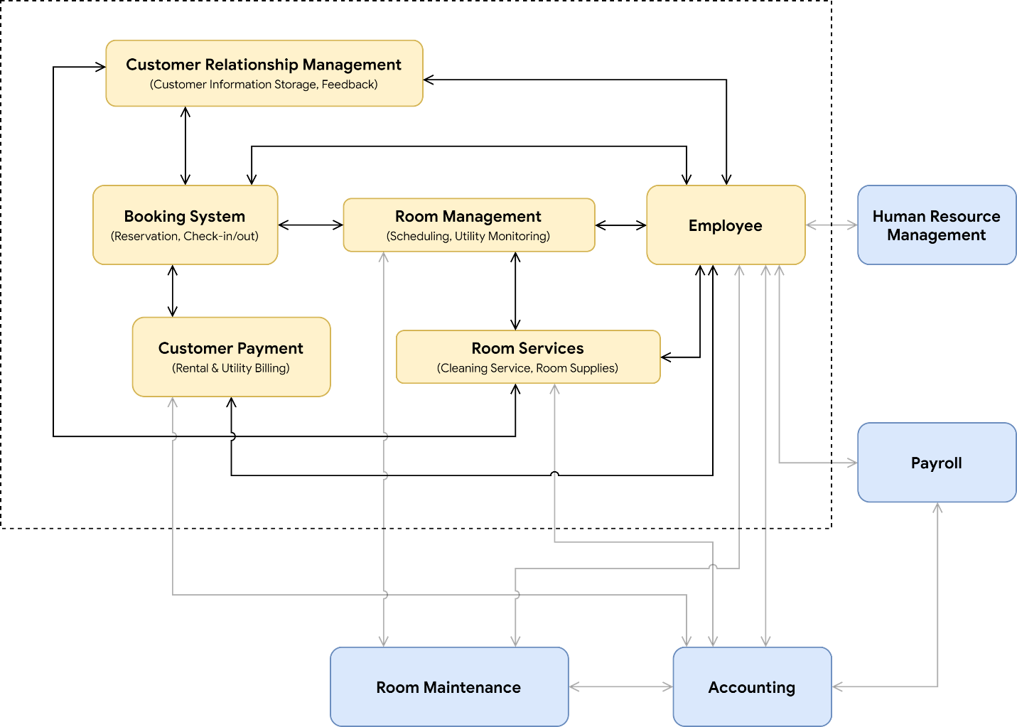

## Subsystem Definitions

### Customer Relationship Management

The subsystem is responsible for the storage of customer information and customer feedback that facilitates the process of communicating with old customers to retain and bring back old customers to generate more income as well as improving overall services.

### Booking

The booking system is responsible for the storage of booking instances that supports the process of rental checking-in and out and reservation for efficient front counter services. Powered by the Room Management subsystem.

### Customer Payment

The payment system supports the process of billing of customer stays, deposits, purchases, and additional room services.

### Room Management

The room management system supports room scheduling and utility monitoring for customer billing and supports.

### Room Service

The room service subsystem is responsible for the cleaning service recording, cleaning service scheduling as well as room and supply management for each branch.

### Employee

The employee subsystem is the main system in the sense that it interacts with most subsystems and is responsible for the storage of employee information, salary, working hour, daily tasks, job application information, and job position.

# Major User View & Operations

|  |  |  |  |  |  |  |  |
| --- | --- | --- | --- | --- | --- | --- | --- |
| **Data** | **Access Type** | **Director** | **Branch Manager** | **Accountant** | **Cleaning Personel** | **Security** | **Customer** |
| All Branches | Maintain |  |  |  |  |  |  |
| Query | **✓** | **✓** |  |  |  |  |
| Report | **✓** | **✓** |  |  |  | **✓** |
| Single Branch | Maintain |  | **✓** |  |  |  |  |
| Query |  | **✓** |  |  |  |  |
| Report |  | **✓** |  |  |  |  |
| All Employees | Maintain |  |  |  |  |  |  |
| Query | **✓** | **✓** |  |  |  |  |
| Report | **✓** | **✓** |  |  |  |  |
| Branch Employee | Maintain |  | **✓** |  |  |  |  |
| Query |  | **✓** |  |  |  |  |
| Report |  | **✓** | **✓** | **✓** | **✓** |  |
| All Customers | Maintain |  |  |  |  |  |  |
| Query | **✓** | **✓** |  |  |  |  |
| Report | **✓** |  |  |  |  |  |
| Branch Customer | Maintain |  | **✓** |  |  |  |  |
| Query |  | **✓** |  |  |  |  |
| Report |  | **✓** |  |  |  |  |
| All Supplies | Maintain |  |  |  |  |  |  |
| Query | **✓** |  |  |  |  |  |
| Report | **✓** | **✓** | **✓** |  |  |  |
| Branch Supplies | Maintain |  |  | **✓** |  |  |  |
| Query |  |  | **✓** |  |  |  |
| Report |  | **✓** | **✓** | **✓** |  |  |
| All Room Services | Maintain |  |  |  |  |  |  |
| Query | **✓** |  |  |  |  |  |
| Report | **✓** |  |  |  |  |  |
| Branch Room Service | Maintain |  |  |  | **✓** |  |  |
| Query |  | **✓** |  | **✓** |  |  |
| Report |  | **✓** |  | **✓** |  |  |
| All Rooms | Maintain |  |  |  |  |  |  |
| Query | **✓** |  |  |  |  |  |
| Report | **✓** | **✓** |  |  |  |  |
| Branch Room | Maintain |  | **✓** |  |  |  |  |
| Query |  | **✓** |  | **✓** | **✓** |  |
| Report |  | **✓** |  | **✓** | **✓** | **✓** |
| All Customer Payments | Maintain |  |  |  |  |  |  |
| Query | **✓** |  |  |  |  |  |
| Report | **✓** | **✓** | **✓** |  |  |  |
| Branch Customer Payment | Maintain |  | **✓** |  |  |  |  |
| Query |  | **✓** | **✓** |  |  |  |
| Report |  | **✓** | **✓** |  |  |  |
| All Room Utilities | Maintain |  |  |  |  |  |  |
| Query | **✓** |  |  |  |  |  |
| Report | **✓** | **✓** | **✓** |  |  |  |
| Branch Room Utility | Maintain |  | **✓** |  |  |  |  |
| Query |  | **✓** | **✓** |  |  |  |
| Report |  | **✓** | **✓** |  |  |  |
| All Reservations | Maintain |  |  |  |  |  |  |
| Query | **✓** | **✓** |  |  |  |  |
| Report | **✓** |  |  |  |  |  |
| Branch Reservation | Maintain |  | **✓** |  |  |  |  |
| Query |  | **✓** |  |  |  |  |
| Report |  | **✓** | **✓** | **✓** | **✓** | **✓** |
| All Rentals | Maintain |  |  |  |  |  |  |
| Query | **✓** | **✓** |  |  |  |  |
| Report | **✓** | **✓** |  |  |  |  |
| Branch Rental | Maintain |  | **✓** |  |  |  |  |
| Query |  | **✓** |  |  |  |  |
| Report |  | **✓** |  | **✓** | **✓** |  |

***Figure 17*** is the result ofan analysis of major user views with respects to the data requirements of each position as well as the basic data operations: maintain, query and report. The main types of data used by each user's view are illustrated in a simpler a cross-reference table as illustrated in ***table 1***.

|  |  |  |  |  |  |  |
| --- | --- | --- | --- | --- | --- | --- |
| **Data** | **Director** | **Branch Manager** | **Accountant** | **Cleaning Personnel** | **Security** | **Customer** |
| Branch | **✓** | **✓** |  |  |  | **✓** |
| Employee | **✓** | **✓** | **✓** | **✓** | **✓** |  |
| Customer | **✓** | **✓** | **✓** | **✓** | **✓** |  |
| Supply | **✓** | **✓** | **✓** | **✓** |  |  |
| Room Service | **✓** | **✓** |  | **✓** |  |  |
| Room | **✓** | **✓** |  | **✓** | **✓** | **✓** |
| Customer Payment | **✓** | **✓** | **✓** |  |  |  |
| Room Utility | **✓** | **✓** | **✓** |  |  |  |
| Reservation | **✓** | **✓** | **✓** | **✓** | **✓** | **✓** |
| Rental | **✓** | **✓** |  | **✓** | **✓** |  |

According to ***table 1***, it can be observed that the Director and Branch Manager completely share the same data access characteristic; thus, both of them are merged into a group of **BranchManagement**. Furthermore, since the accountant, cleaning personnel and security share similarities in data access and requirements. They also are the positions that bound to only a branch; therefore, the name of **BranchEmployee** is given to the group. Lastly, customers also have their own Customer Users' Views because of their unique data requirements.

### **BranchManagement** Users' View

* **Director** responsible for making the overall business decisions; therefore, extensively relevant summary reports are mandatory.
* **Branch Manager** is considered to be a receptionist at a branch responsible for managing room reservations, payments, rentals, payments, etc.

### **BranchEmployee** Users' View

* An **accountant** is responsible for managing a branch's supplies, incomes, and expenses.
* **Cleaning Personnel** responsible for room resupplying and cleaning services. Cleaning personnel can withdraw supplies via an accountant directly.
* **Security** is responsible for the overall security of an apartment branch. They are allowed to access information that can be helpful while in duty. That information includes branch employees, room information, and customer rental.

### **Customer** Users' View

* A **Customer** has access to gain knowledge, that helps to generate awareness of the business, room availability, branches as well as reservations using Bright House's public online channels. A customer can also keep track of the feedback that they submitted.

# User's Requirement Specifications

## BranchManagement

### **DATA REQUIREMENTS**

#### BRANCH

Bright House apartment has multiple branches scattered throughout the eastern region of Thailand. Each branch is managed by has employees which also include the branch manager who responsible for the daily operation of the business. The description of branch data includes the manager name, full branch name, up to 3 telephone numbers, address, fax number, email address, opening hours, and date of establishment. Additionally, the date that the manager gets his or her position at the current branch is also recorded.

#### EMPLOYEE

As a manager, the employee data is used to consider when an employee applies for a job. Moreover, it is also used to estimate the salary of employees. Employees must provide Citizen ID Number, First name, Last name, Phone numbers, Nationality, and Work experience. Additionally, gender, work position, and associated branch number.

#### CUSTOMER

To facilitate the growth of the business by using customer relationship management, Bright House will emphasize on unifying customer information between branches to create a seamless data boundary between branches. All personal information given by the customers will be stored in terms of first name, middle name, last name, nationality, identification number or passport number, date of birth, contacts such as emails, Facebook account, and telephone numbers. As well as individual customer feedback that is also important for business growth. After receiving customer feedback, a branch manager will keep a record of those.

#### SUPPLY

Each supply that belongs to each branch must be recorded by a branch accountant to increase the transparency; therefore, item name, item type, time of the stock transaction as well as the quantity and transaction types (e.g. incoming, outgoing) must be stored. Additionally, the name of the person in charge is also required and will also be recorded as well.

## ROOM SERVICE

To ensure that the service will cover every customer in each branch and facilitate the scheduling of works, each record of room service will have the timestamp of service request creation, the status of the service (e.g. scheduled, in-progress, finished), the target room number, the name of the cleaner, the time that the service is finished, the type of the service and the subtasks will also be recorded.

#### ROOM

Since each branch manager has to take care of all the rooms in the apartment, room information should be exposed and consist of the room number, room size, furniture list, room supply list, and location (e.g. branch, building, floor number). Room numbers are not unique across all branches.

#### CUSTOMER PAYMENT

To enable a systematic way to generate financial reports, any customer payment such as utility payment, rental payment or extra cleaning service payment will be recorded in terms of the transaction time, the amount, the name of the customer and the money receiver name.

#### ROOM UTILITY

Since utility must be manually kept tracked for each room, before any rental, a branch manager must record the room's water and electricity initial unit when customer check-in and the final amount unit when customer check-out to calculate the total utility cost. Time Recorded, the room number, the rental number, the number of units of electricity, and the number of units of water will be recorded.

#### RESERVATION

When a customer sends a reservation message to a branch manager, the manager should keep important information such as customer name, the time which the reservation starts, duration of the reservation, room number, the name of a responsible employee, the time which the reservation is created, and special request note. There is no limit on the number of reservable rooms.

#### RENTAL

To secure customer rental data, rental number, rental time, rental duration, rental ending time, rental fee, rental room number, the branch, rental customer name, additional remark and rental type (e.g. daily or monthly) are required and need to be recorded to facilitate in the process of generating useful reports. Please note the rental number is unique across all branches.

### **TRANSACTION REQUIREMENTS**

#### DATA ENTRY

1. Enter the details of a new **Branch** (such as branch ID 1; "Tanachon", manager ID 1, ...).
2. Enter the details of a new Member of an **Employee** at a branch (such as Supachai Jaidee).
3. Enter the details of a new **Customer** who check-in for the first time at the front counter at a branch. (such as Peter Tarlay).
4. Enter the details of a new **Room** in a Branch (such as room number 203 is a superior room, which consists of a bed, a television, a wardrobe, and a safe, located on the 2nd floor at Tanachon branch).
5. Enter the details of new **Customer Payment** (such as payment for room number 203 rented by Peter Tarley).
6. Enter the details of a new **Room Utility** record (such as an electricity utility record of room number 203 on 23/5/2019 is 3486 units).
7. Enter the details of a new **Reservation** record received from a customer email or phone call (such as a reservation record for Peter Tarlay booked on 10/5/2019).
8. Enter the details of a new **Rental** at a branch (such as customer Peter Tarlay is renting and staying at room number 203 at Tanachon branch as a monthly rental started 23/05/2019).

#### DATA UPDATE/DELETION

1. Update/delete the details of a **Branch.**
2. Update/delete the details of a member of **Employee** at a branch.
3. Update/delete the details of a **Customer** including feedback**.**
4. Update/delete the details of a **Room** in a Branch.
5. Update/delete the details of a given **Customer Payment** at a given branch.
6. Update/delete the details of a **Room Utility** at a given branch.
7. Update/delete the details of a room **Reservation** made by a customer **at a given branch.**
8. Update/delete the details of a room **Rental** at a given branch.

#### DATA QUERIES

1. List the details of **branches** in a given area of the Eastern region of Thailand.
2. List all details of **employees** given an employee ID, name, surname, or branch name.
3. Identify the total number of **employees** in all branches.
4. Identify the average salary of **employees** in each position, gender, branch, ordered in ascending order.
5. List all active branch **managers** ordered by the branch address.
6. List **employee** details by a given position, name, ID, and Date of birth.
7. Identify the total **employee** payroll for a day, week or month.
8. Identify the total number of unique **customers** that have ever visited at least one branch.
9. List unique **customers** that have ever visited at least one branch.
10. Identify the average age of **customers** from each nationality.
11. List **customer** details grouped by a given branch.
12. List **customer** details by a given duration from their last visited time ordered by the duration.
13. List details of **customers** who recently stay more than one branch of Bright House ordered by descending order.
14. List details of **supplies** that are used the most by any branches.
15. Identify the average number of **supplies** left at the end of every week grouped by each the name of the supply.
16. List room details with a status of the **rental** by a given branch or area.
17. List all **rooms** that currently have guests staying grouped by room size.
18. List the details of **payment transactions** along with full customer name and nationality that has the top-10-most transaction amounts in a given month.
19. Identify the average **customer** **payment** amount grouped by transaction type.
20. Identify the average amount of money in **customer payments** grouped by customer's nationality, and ordered by month.
21. Identify the **customer payment** that has the highest amount of money grouped by month, customer's nationality.
22. List the **customer payment** by a given rental number and customer name.
23. Identify the average amount of **customer** **payments** grouped by month.
24. Identify the frequency of **rental** grouped by month.
25. List all **rentals** that will be **expired** within a given time range at a branch.
26. List all **rooms** that will be **free** within a given time range at any branch in a case the customer must be redirected to another branch.
27. List all **rentals** in any branches associated with a given **customer**.
28. List all **room services** done to a specified **room** within a branch.
29. List all **room services** done to a specified **rental** within a branch.
30. Identify the average duration of **customer rentals** within any branch.
31. Identify the average duration of stay of all **customer** Visa within any branch.
32. List all **branches** ordered by the total number of free rooms within a given time range.
33. Identify **months** that have a high amount of reservations.
34. Identify **months** that have a high amount of income.
35. Identify the difference between income from rentals & additional cleaning services and expenses from room supply during high and low seasons.
36. List **feedback** reported by **customers** categorized by branches.
37. Identified the total number of customer **feedback** in each branch.
38. Identified the total number of customer **feedback** grouped by categories.
39. Identified the average number of customer **feedback** per rental.
40. List customer **feedback** from all branches in a given period of time.

## BranchEmployee

### **DATA REQUIREMENTS**

#### EMPLOYEE

The data required on employees include employee number, name, surname, citizen ID, date of birth, address, position, gender, phone number. Each employee will have their own position, but they can have more than 1 phone number.

#### CUSTOMER

For the employee, they will need to retrieve some of the customer data including the customer's name and surname, and phone number for the cleaning personnel since they may need to make an appointment with customers.

#### SUPPLY

Accountant of each branch is also responsible on order and check items that have been used on room supply service for a long time since cleaning personnel is the one who responsible on refilling customers room with items include in-room supply services. They also should be able to see the branch's supply data.

## ROOM SERVICE

To improve customer experience and hygiene inside a room, each rental will come with a cleaning service that will be scheduled based on intervals. There are 2 types of room services: cleaning and supplying. Cleaning service has multiple subtasks all of which will be done by cleaning personnel. The subtasks include wiping the table, sweep the floor, mop the floor, clean the bathroom, change towels, change sheets and pillowcases. Each cleaning personnel has the ability to keep track of their processes. Lastly, the customer can request for additional room services at a price.

#### ROOM

Every employee needs to know room data. However, each position needs a different set of data. For instance, the Accountant needs to know room number, room size, furniture list, room supply list, while cleaning personnel need to know the building, room number, furniture list, room supply list. As for security, they only need to know about Building, floor number, room number.

#### CUSTOMER PAYMENT

All customer payments will be monitored by a branch accountant. All branch accountants can verify customer transactions to ensure the transparency of all transactions within their respective branches.

#### ROOM UTILITY

The cost of the utility of each room is exposed to a branch accountant for the creation of monthly financial reports. An accountant is also allowed to query utility data for the use of verifying the branch financial ledger.

#### RESERVATION

Some reservation information is exposed to the branch accountant, cleaning personal and security in order to help in various processes such as cleaning and security scheduling as well as income and expense estimations.

#### RENTAL

Rental information is used to schedule and plan room servicing and security by exposing room data such as the rental type and the date which the customer will check-out. Moreover, security personnel can use the data to efficiently adapt their security routine based on the number of room occupied.

### **TRANSACTION REQUIREMENTS**

#### DATA ENTRY

* Enter the data of a **Room Service** (such as room 203 with the superior room size and being rent monthly will receive "น้ำเปล่าขวดใหญ่", "กาแฟซอง", "สบู่ก้อน", "หมวกคลุมผม". Each with a quantity of 2).
* Enter the details of a new transaction of **Supply** (such as "น้ำเปล่าขวดใหญ่แพ็ค" is being transferred into Tanachon Branch with the quantity of 10 pcs. by Supachai Jaidee).

#### DATA UPDATE/DELETION

* Update/delete the details of a **Room Utility** at a given branch.
* Update/delete the details of a **Customer Payment** at a given branch.
* Update/delete the details of a **Room** at a given branch.
* Update/delete the details of a **Supply** at a given branch.
* Update/delete the details of a **Room Service** at a given branch.

#### DATA QUERIES

1. List the number, full name, working hours, position of **Employees** by a given branch sorted by name alphabetically.
2. List the details of **Supplies** by a given branch and supply name, ordered by quantity in ascending order.
3. List details of **supplies** that are used the most by a branch.
4. List the details of **Room Services** for cleaning personnel.
5. List the number, floor, and building of **Rooms** that have occupied by customers.
6. Identify the total sum of **Customer** **Payment** within a given period in a branch.
7. Identify the **Room Utility** cost for a monthly rental within a branch.
8. Identify the total **Room Utility** cost for all monthly rentals within a branch.
9. List all **Utility** records of a given Room and given rental number.
10. List the room number, check-in time, check-out time and type of **Rental** for the process of planning and scheduling room services and security routine.
11. List **Customer** **Payments,** that associates with a branch, by time and transaction type.
12. List room number, customer name, rental type, deposit, rental amount, as well as **supplied** used by the **room**.
13. List all **rentals** that will be **expired** within a given time range at a branch.
14. List all **rooms** that will be **free** within a given time range at any branch in a case the customer must be redirected to another branch.
15. Identify room number and rental type of branch **reservations** that are scheduled within a given time range.
16. List all **room services** done to a specified **room** within a branch.
17. List all **room services** done to a specified **rental** within a branch.
18. List all **room services** done by a given **employee** in a branch.
19. List all **rental check-in** that is supervised by a given **employee**.
20. List all **rental check-out** that is supervised by a given **employee**.
21. List periods that have the maximum number of cleaning service requests within a branch ordered by descending order.
22. Identify the average number of unique **customers** per week within a branch in a given time range.
23. Identify the average number of new **customers** per week within a branch in a given time range.
24. Identify which **room** has the longest rental duration from any customer with a given period.
25. Identify which periods will have the highest **utility** usages in terms of unit or cost in a branch.

## Customer

### **DATA REQUIREMENTS**

#### BRANCH

A customer has access to the basic information of branches such as the branch's name, location, office working hours, room capacity, telephone numbers, fax number, and email address.

#### ROOM

Customers can access the total number and details of available rooms in order to select the room for booking or reservation. Moreover, customers should know room size, floor number, the building number are of which can affect room prices.

#### RESERVATION

A customer will be the person who provides reservation information. They should be able to access the data about their booking.

### **TRANSACTION REQUIREMENTS**

#### DATA ENTRY

Customer does not enter the data by themselves. It is the duty of a branch manager.

#### DATA UPDATE/DELETION

Customer does not update/delete the data by themselves. It is the duty of a branch manager.

#### DATA QUERIES

1. List the details of **Rooms** in each branch.
2. List the details of a **Reservation** that a particular customer has reserved. (A customer can reserve a room and get the details of the Reservation that they have made)
3. List the details of **Branches** by a location given by a customer.
4. List the details of **Available rooms** in each branch.
5. List the **Contact** details in each branch.
6. List the **Feedback** that is submitted by the customer who gave the feedback.

# System Specifications

## Initial Database Size

* There are approximately 80 members of staff working in 10 branches. There is an average of 8 staff at each branch.
* There are approximately 134 rooms in all branches. Each branch has more than 10 rooms and a maximum of 15 rooms.
* There are approximately 220 customers for all branches in 1 day. Each branch has about 22 customers in 1 day.
* There are approximately 20 reservations for all branches in 1 day. Each branch has about 2 reservations in 1 day.
* There is approximately 30 payment transaction for all branches in 1 week. Each branch has about 3 payments in 1 week.
* There are approximately 500 supplies for all branches. Each branch has about 50 supplies.

## Database rate of growth

* Approximately 50 new customers will be added to the database across all branches each month. If customers did not rent the room from the last time within two years, the record will be deleted.
* Approximately 300 new rentals will be added to the database across all branches each month. The record will be deleted after 2 years after the creation of the record.
* Approximately 10 new employees join and leave the company each month. The data of employees will be deleted after 1 year after the employee leaves the apartment.

## Types and average number of record searches

* Search for detail of branch - approximately 10 per day.
* Search for detail of room - approximately 50 per day (during low season), approximately 400 per day (during high season).
* Search for an employee in each branch - approximately 20 per day.
* Search for detail of customers - approximately 20 per day.
* Search for detail of rental - approximately 100 per day.

## Networking and shared access requirements

All braches should be securely networked to a centralized database located at Bright House's main office in Soi Buakhao. The system should allow for 1 to 2 people concurrently accessing the system from each branch.

## Performance

* During opening hours, but not during peak periods, expect less than a 1-second response for all single record searches. During peak periods, expect less than a 3-second response for each search.
* During opening hours, but not during peak periods, expect less than a 3-second response for each multiple record searches. During peak periods, expect less than a 5-second response for each search.
* During opening hours, but not during peak periods, expect less than a 1-second response for all single record each update/save. During peak periods, expect less than a 3-second response for each update/save.

## Security

* The database should be password-protected.
* Each member of staff should be assigned database access privileges appropriate to a particular user view.
* A member of staff should see only the data necessary to do his or her job in a form that suits what he or she is doing.
* A client should see only their own booking data and personnel details using the Bright House apartment website.

## Backup and recovery

The database should be backed up daily at 6 a.m. Since Pattaya is a night tourist city, most people do not sleep at night. They will sleep in the morning. People also wake up late so most people begin their daily life at noon.

## Legal issues

Bright House database holds data from staff and clients. Data privacy is a personal data must be kept legally. Legal issues must be complied with should be investigated and implemented.